# ADX Interpretation Question

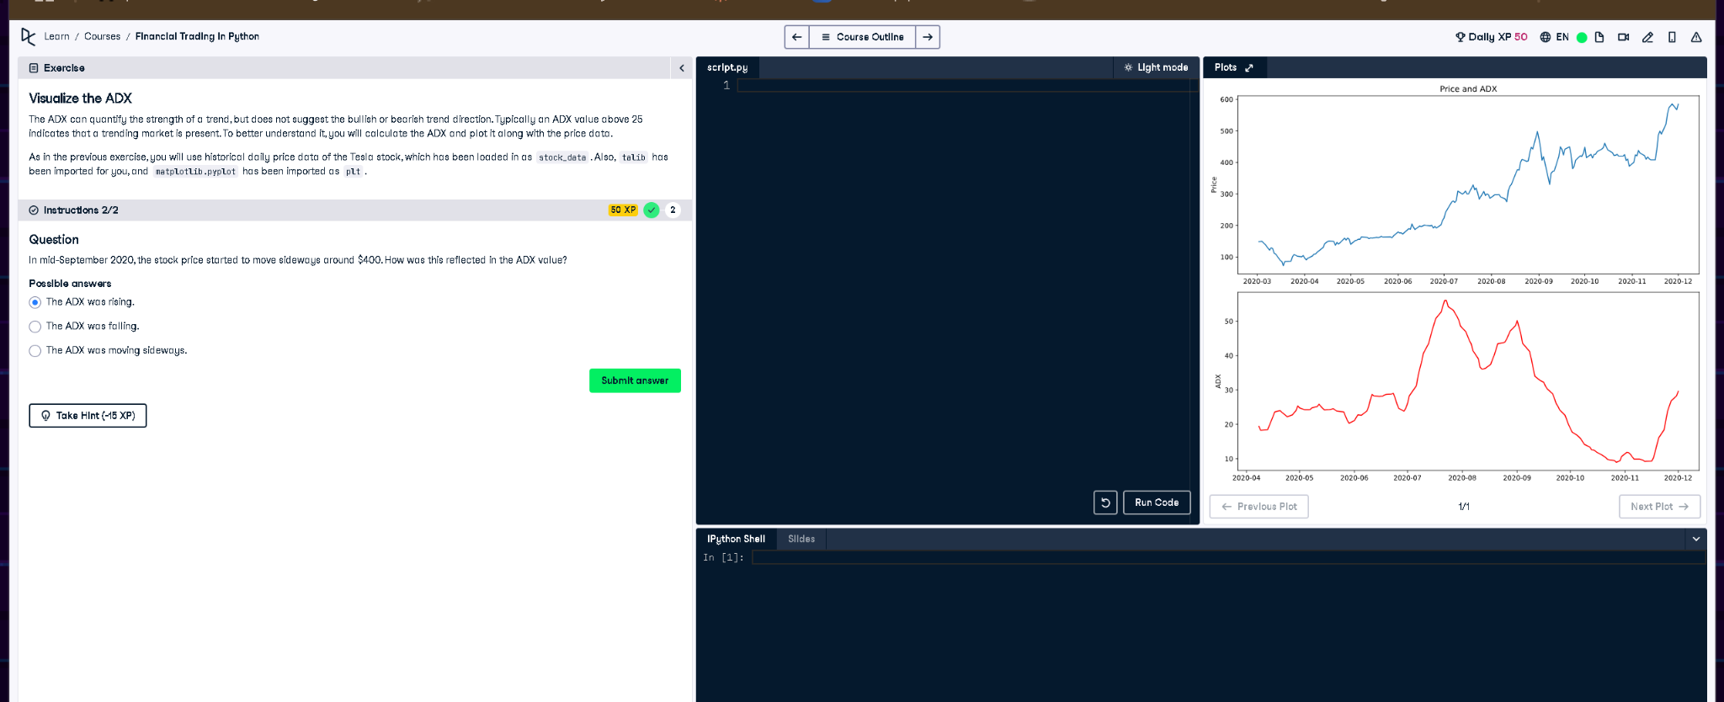

## Full Answer

Question:  
In mid-September 2020, the stock price started to move sideways around $400. How was this reflected in the ADX value?  
  
Answer:  
The correct answer is: The ADX was falling.  
  
Explanation:  
The ADX (Average Directional Index) measures trend strength, not direction. Around mid-September 2020, the price leveled off near $400, showing a loss of directional movement. As a result, the ADX decreased sharply—visible in the chart—indicating weakening trend strength even though the price was relatively stable.

## Simple Explanation (50 Words)

When Tesla’s price moved sideways around mid-September 2020, the ADX line dropped. This drop signals a weakening trend. Even though the price stayed around $400, the falling ADX showed there was no strong upward or downward movement, meaning the trend was losing strength.